GRAECALIS BUILDING MANUAL
Graecalis is an aerobatic glider designed by Voloinpendio.it and produced in full composites version 3.0.
Entirely designed in cad 3d has a BEX1809 profile.
2 versions are released from our production:
-Standard (glass fibre painted in mould)
-Carbon (painted carbon in mould)
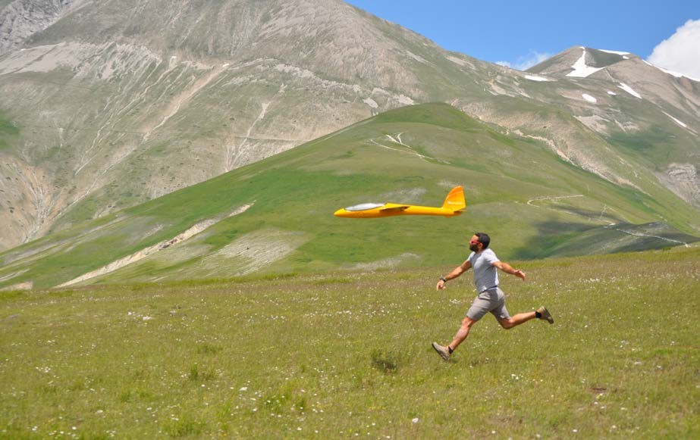
TECHNICAL DATA Graecalis 3.0:
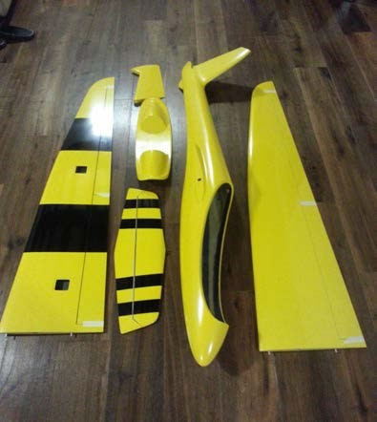
wingspan: 2.9m
airfoil: Bex 1809
length: 1.6m
weight: about 5200 gr. wingload: 56,8 dm2

KIT CONTENTS
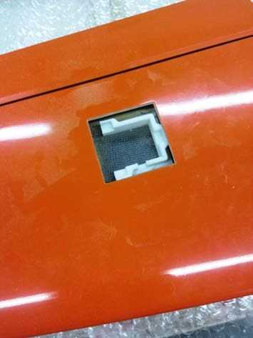
- Fuselage
- Composite wings
- Steel joiner (optional carbon joiner)
- composite elevator
- rudder
- canopy
- VTR cockpit
- 1 vtr tube
- 2 Brass tubes for wing plugs
- 2 wood ribs
- 1 servo base
- 4 wing servo holders
- 4 servo cover in VTR

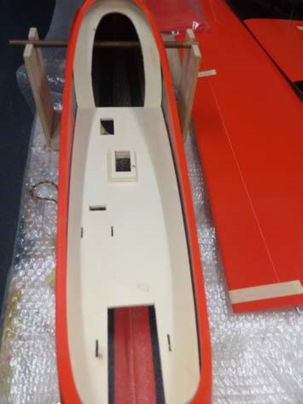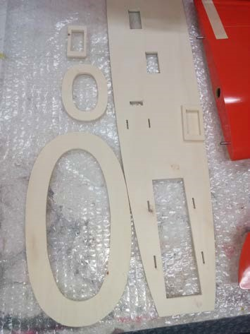

BUILDING ELEVATOR
Make a hole of 5 mm to 6.5 cm from LE
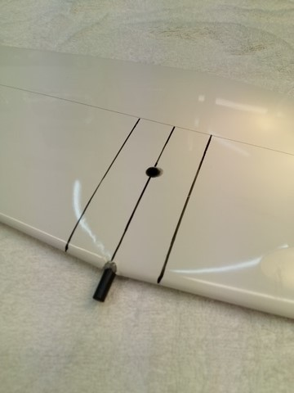
6
,
5

c
m
glue a piece of wood and a nut
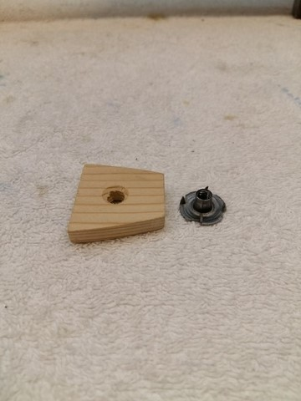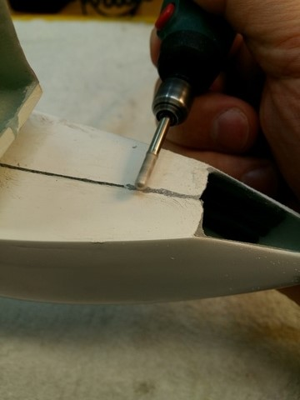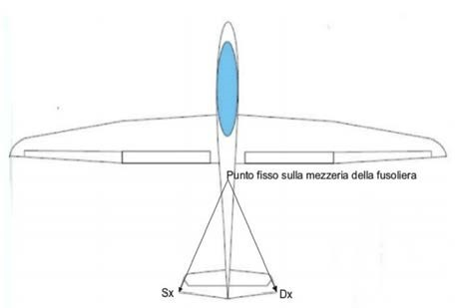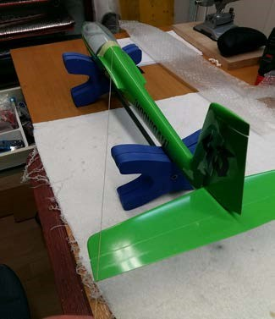

BUILDING RUDDER
make cuts for hinges 2 cm from top and bottom

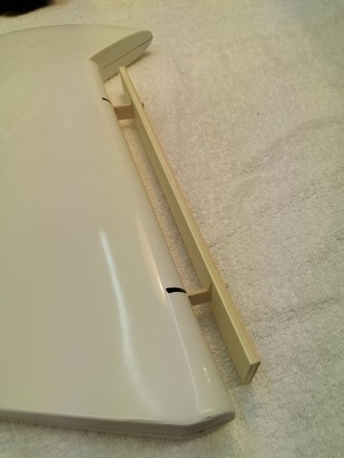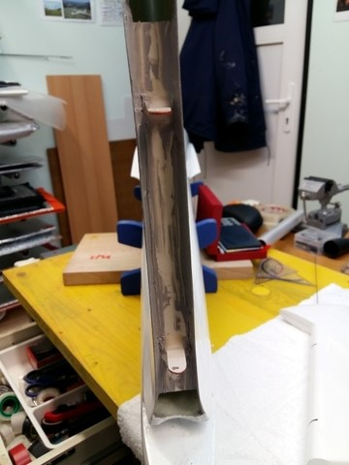
2

c
m
2

c
m
2

c
m
2

c
m
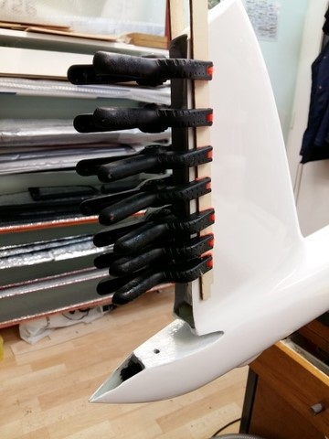

ASSEMBLING WING SERVOS
In our kits we supply 4 wing servo mount (for KST 225mg servos), fiberglass covers, and vetronite horns for flaps and ailerons.
For the gluing of the servo mount and the horns, use epoxy resin thickened with thixotropic and microfibre.
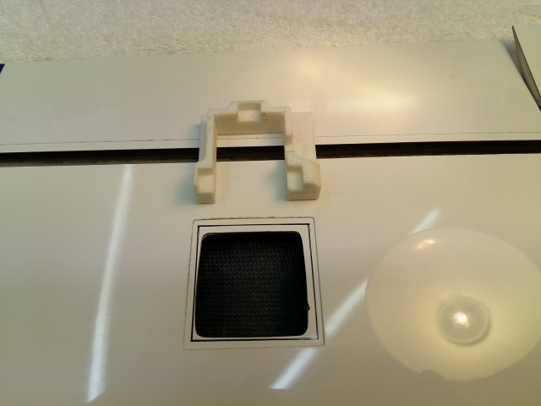
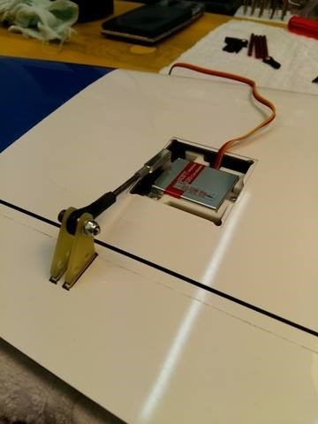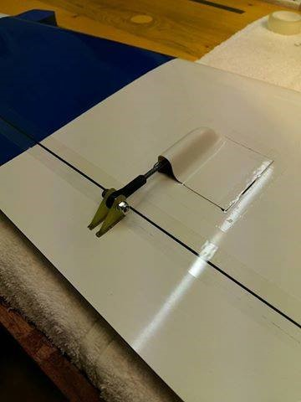

ASSEMBLING FUSELAGE

To fix the wings to the fuselage as best as possible, glue the fiberglass tube holder and the brass tubes supplied in the kit, taking care to give the wings the same incidence and above all checking the longitudinal dihedral, which must be 1 ° positive

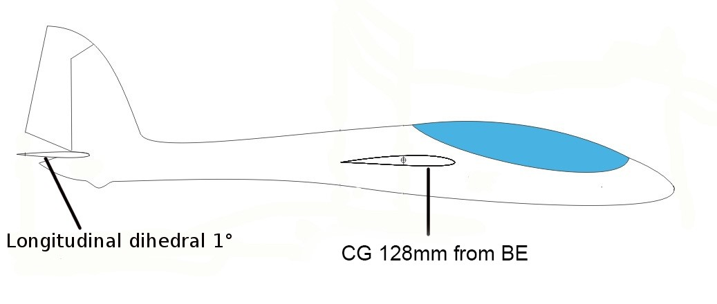
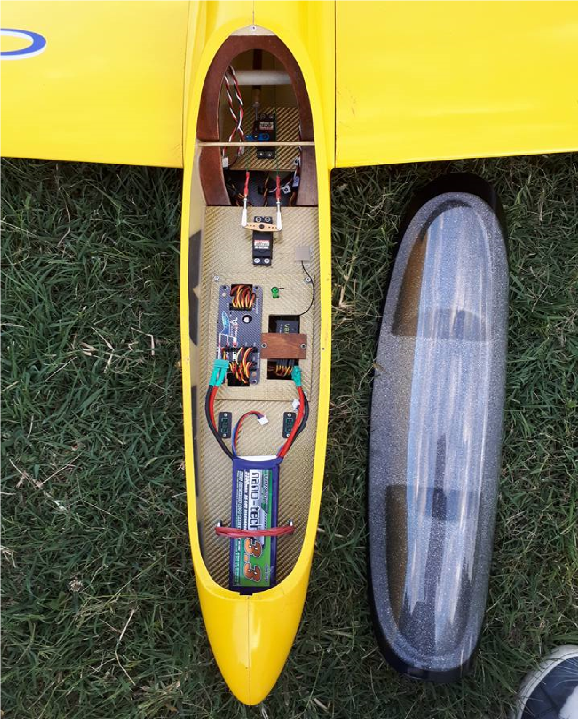
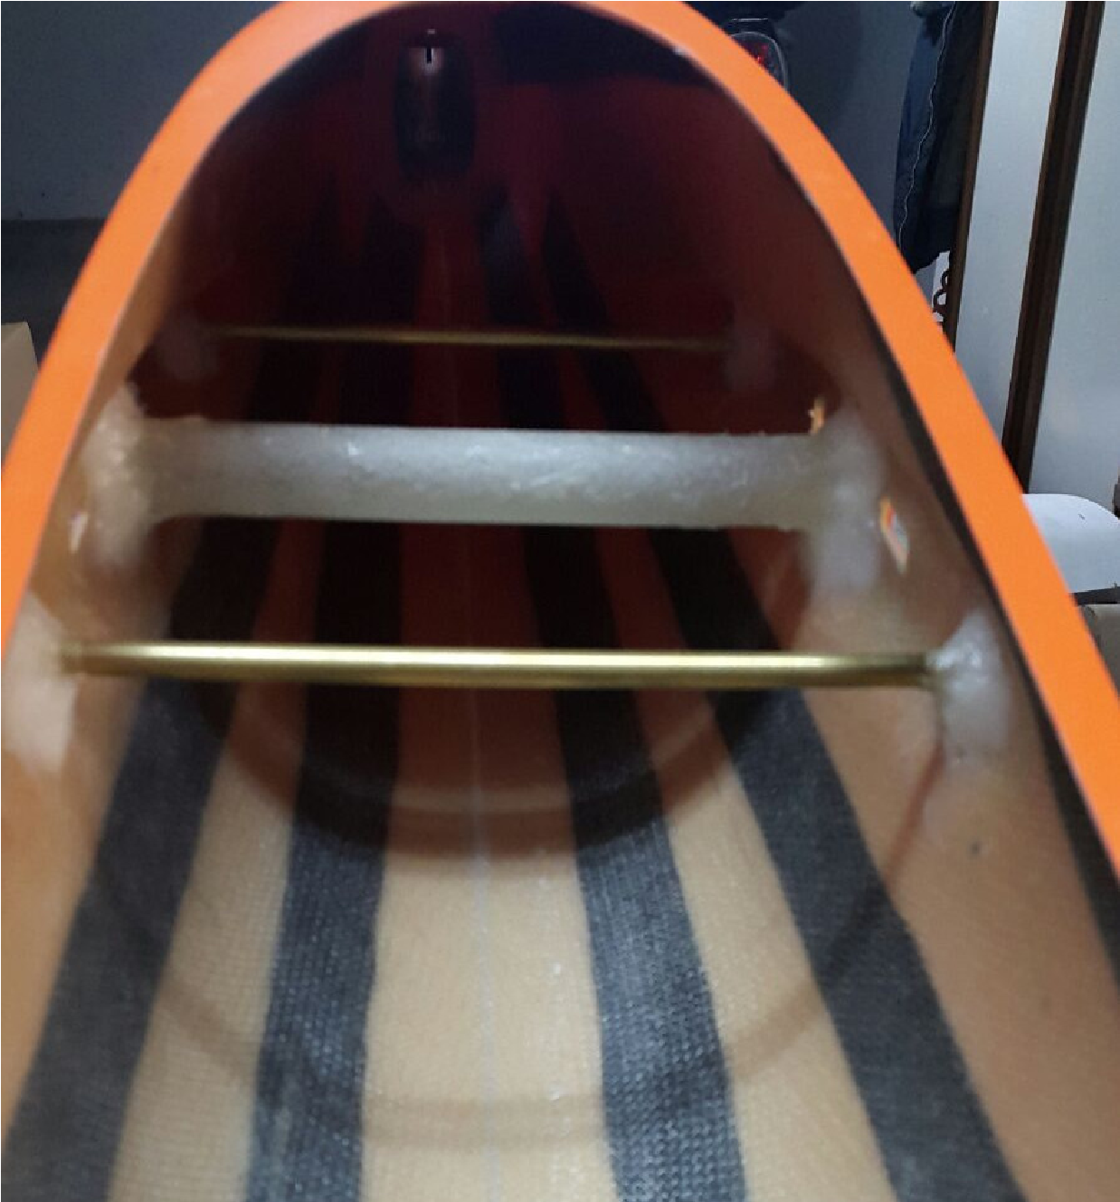

CANOPY
To glue the canopy to the cockpit use thickened epoxy resin with thixotropic. At the following address you will find a video guide on how to best perform this operation https://www.youtube.com/watch?v=QhLLIkHFyXg
